**Popular Music Politics**

**MUSIC 4081 [20] / MUSIC 5010 [30]**



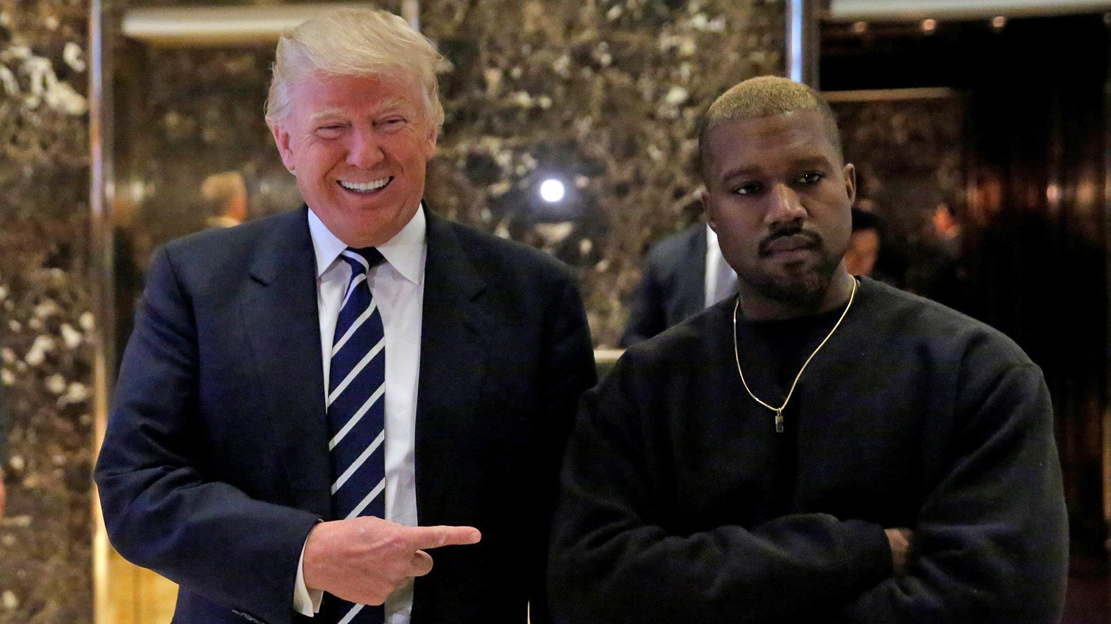

**Course Handbook**

**2018-9**

**Contents**

Contact Information 3

Course Structure and Classes 3

Moodle 6

Aims and Learning Outcomes 6

Assessment 7

Extensions and Good Cause 7

Reading 7

**Contact Information**

Course leader:

**Dr John Williamson** -[John.C.Williamson@glasgow.ac.uk](mailto:John.C.Williamson@glasgow.ac.uk).

Please email if you have any problems relating to the course or need to meet at any stage. I don’t have regular office hours but can always be contacted by email to set up a meeting if required.

**Other lecturers:**

**John Markey [JM] -** [j.markey.1@research.gla.ac.uk](mailto:j.markey.1@research.gla.ac.uk) .

**Eileen Karmy Bolton [EKB]** [e.karmy-bolton.1@research.gla.ac.uk](mailto:e.karmy-bolton.1@research.gla.uk)

**Course Structure and Classes**

The course begins by examining sociological themes relating to **gender, sexuality, race and the relationship between popular music and the state**.

Thereafter the focus will be on a combination of different popular **genres and places** (sometimes simultaneously) to show how these issues play out in different contexts across the world.

Each week the class will take a slightly different format. A three-hour session is often hard going, so there will be a variety of teaching formats and the classes will usually be two parts. There will normally be a lecture (60-75 minutes) to begin with a break followed by a discussion / seminar style second period. Sometimes these will be as a large group, other times in two smaller groups.

For each class there will be a short pre-class task or reading which will feed in to the class. Please make sure that you come prepared having read it and (if possible) bring a connected device (laptop, tablet etc.).

These take place in **Room 2, 14 University Gardens** unless other advised.

**Week 1**

**10 January**  
**Introduction: Politics and Pop Songs [JW]**

What is meant by politics and how does popular music relate to it? This opening session lays out some thoughts on what is to come on the course. It stresses broad definitions of both popular music and politics. It locates politics as a site of power relations and of contested views about what popular music is about.

**Week 2**

**17 January**  
**Themes: Gender and Sexuality [JM]**

How does popular music deal with gender roles? Does it reinforce stereotypes, or can it be liberating? This class examines such issues and invites students to think about how gender has shaped their attitude towards, and experience of, popular music. It also addresses sexuality asking how it is constructed within popular music and what is at stake in such processes.

**Week 3**

**24 January**  
**Genres and Themes: Hip Hop and Censorship [JM]**

Rap has been both one of the most successful forms of popular music in recent years and one of the most controversial. Is it a liberating music for disadvantaged groups or a form of misogyny which reinforces gender and sexuality stereotypes? This session addresses such issues, locating rap within broader political processes.

It will also raise some questions as to whether there should be limits to musicians’ freedom of expression. If so, why? If not, why not?

**Reading:** Stratton, J. 2014. ‘Popular Music, Race and Identity’, in Bennett, A. and Waksman, S. (eds) *The Sage Handbook of Popular Music*. London: Sage.

**Week 4**

**31 January**  
**Themes: Popular Music and the State [JM]**   
Recent years have witnessed increasing attempts by governments to devise policies for popular music – an art form often previously been portrayed as being a free market form *par excellence*. Drawing largely under the experience of the UK, this session outlines the reasons for such developments, locating them within broader socio-political and cultural trends. It seeks to ask whether the state should simply leave pop alone or if it is compelled to intervene.

**Week 5**

**7 February**  
**Places: USA / Trump, Pop Music and Elections [JW]**

What impact, if any, does popular music have on the electoral process? Can popular musicians play a meaningful part in the democratic process or does this inevitably lead to the “dumbing down” of politics. Can musicians’ impact ever extend beyond celebrity endorsement? This class will focus on the US Presidential election on 2016 and the mid-terms of 2018, looking at the role and influence of (among others) Katy Perry, Taylor Swift, Beyonce, Joy Villa, Ted Nugent and Kanye West in the campaigns.

**Week 6**

**14 February**  
**Reading Week**

**Week 7**

**21 February**  
**Places: Chile / Totalitarianism [EKB]**   
What roles does music perform in totalitarian regimes? Must it act as a prop to such regimes or can it provide spaces for critique? Does the very practice of music pose problems for totalitarian regimes? Do different genres have different impacts? These and other issues will be examined via a study of music under the regime of Chilean dictator, Augusto Pinochet.

**Week 8**

**28 February**

**Genres and Place: Guns and the politics of country [JW]**

Country music has often been portrayed as bastion of conservative values that reflects rural lifestyles in middle America. It remains not only one of the most popular genres of music in the USA but has enjoyed ever greater international reach with the success of acts like Shania Twain, The Dixie Chicks and Taylor Swift.

More recently, the shooting at a country festival in Las Vegas that left 58 people dead raised further questions about the genres uncomfortable relations with the gun lobby when the Country Music Association (CMA) attempted to prevent journalists asking participants its annual awards ceremony about ‘tragedy’, ‘gun rights’ and ‘political affiliation’.

The class, therefore, raises questions about censorship and freedom of speech, and how expressing different political viewpoints impacts on artists within the country music industry.

**Week 9**

**7 March**  
**Places: The politics of contemporary Scottish popular music [JW]**

The independence movement (and referendum in 2014) has been closely connected with popular music of different types. Putting this in historical context, the class will examine whether this is beneficial to either the politicians or the musicians involved. It will also attempt to unravel notions of what it is to be Scottish and national identity more generally as they relate to popular music.

**Week 10**

**14 March**  
**Presentations** [JW/ EKB and others]

Presentations will take place during the allocated class hours and one other day during the week, details to be advised on Moodle.

**Week 11**

**21 March**  
**Places meet Genres: London and the politics of Grime [JW]**

With its origins firmly in London, the commercial success of grime (in the shape of Mercury Prize wins for Skepta and Stormzy) have brought not just the music, but its associated politics to a wider audience. The class will examine the origins of the music in relation to class, race and geography and then consider controversies surrounding its links with gangs, violence and drugs as well as its more positive associations: community building and empowerment as well as grime artists campaigning on issues of local and national importance, notably in the aftermath of the Grenfell Tower fire.

**Moodle**

Course content and announcements will appear on Moodle on a week to week basis and assessments will also be submitted via Moodle. Please check regularly and pay attention to any changes of plan, instructions, etc.

**Aims and Learning Outcomes**

**Aims**

This course will provide the opportunity to:

* Develop student's critical understanding of, the politics of Popular Music.
* Introduce and discuss political theories, beliefs and movements in relation to Popular Music.
* Introduce and theorise the relationship between the state and Popular Music
* Critically examine the development of Popular Music policies, in the UK and beyond.
* Critically evaluate the roles which gender and sexuality play in the production and consumption of Popular music
* Examine the limitations to freedom of expression in popular music
* Develop students' skills (including verbal and written) in the presentation of ideas relating to the politics Popular Music

**Intended Learning Outcomes**

By the end of this course students will be able to:

* Understand and critically evaluate the politics of Popular Music in a range of contexts
* Critique key academic and other texts relating to the politics of Popular Music
* Display a critical understanding of key concepts such as politics, gender, policy and censorship
* Engage critically with academic texts which deal with Popular Music
* Reflect critically upon the interaction of Popular Music texts and audiences
* Reflect critically upon their own tastes in Popular Music
* Communicate verbally and in writing the different politics of Popular Music

**Assessment**

This is in two parts.

**Presentation (20%)**

1 oral presentation lasting ten minutes on or around **Thursday 14th March.** A schedule will be posted on Moodle in advance. All scripts and slides for presentations should be submitted in advance by email as per Moodle instructions.

Marks and feedback for the presentations will be posted on Moodle by **28th March 2019.**

**Essay (80%)**

1 essay of up to 3,000 words to be submitted by 12 noon on **Tuesday 16th April 2019** (60%). A list of essay questions and further instructions will be provided at the start of February.

8Any students taking the 30-credit version of the course will be required to do an essay of up to 5,000 words and the presentation.

Marks and feedback for the essays will be posted on Moodle by **Tuesday** **7th May**.

Any delays and reasons will be notified.

**Good Cause and Extensions**

If you are away from the University for any length of time due to illness or other reasons, please make sure you update MyCampus accordingly as this will be necessary for any Good Cause claims to be considered by the exam board.

If you need an extension for an individual piece of work, please contact me on [John.C.Williamson@glasgow.ac.uk](mailto:John.C.Williamson@glasgow.ac.uk). The maximum length of extension that can be granted by a course leader is 3 days.

**Reading**

You are encouraged to read widely beyond the set readings and material listed for each week, especially when it comes to preparing presentations and essays.

The following books are good overviews of the subject of (popular) music and politics of different styles and degrees of complexity. These are all helpful introductions to the subject. It is important that you are familiar with them.

It is also worth noting that the nature of the subject is such that not all the topics have been written about extensively by academics, so it is often necessary to use secondary sources (journalism, reports, websites, etc.). However, you should do so with caution, always questioning the validity and reliability of the sources.

**General**

Garratt, J. 2018. *Music and Politics: A Critical Introduction.* Cambridge: Cambridge University Press.

Randall, D. 2017. *Sound System: The Political Power of Music.* London: Pluto.

Street, J. 2011. *Music and Politics.* London: Polity.

The following also include material that is pertinent to the course. A wider reading list covering some of the topics covered in class will be on Moodle.

Ballinger, R. 1999. “Politics” in B. Horner and T. Swiss (eds.) *Key Terms in* *Popular Music and Culture,* Oxford: Blackwell, pp.57-70.

Brabazon, T. 2010. *Popular Music: Topics, Trends and Trajectories.* London: Sage.

Cloonan, M. 2007. *Popular Music and the State*. Aldershot: Ashgate.

Frith, S. 1983. *Sound Effects* London: Constable.

Garofalo, R. (ed.) 1992. *Rockin' The Boat.* Boston: South End Press.

Goehr, L. 1994. “Political Music and the Politics of Music”, *Journal of Aesthetics and Art Criticism*, 52:1, pp.100-112.

Green, L. (1999) “Ideology” in B. Horner and T. Swiss (eds) Key Terms in *Popular Music and Culture,* Oxford: Blackwell, pp.5-17.

Homan, S. Cloonan, M. and Cattermole, J. 2016. *Popular music industries and the state: policy notes*. London: Routledge.

Longhurst, B. and Bogdanovic, D. 2014. *Popular Music and Society.* Cambridge: Polity, 3rd edition.

Peddie, I (ed.) 2006. *The Resisting Muse: Popular Music and Social Protest.* Aldershot: Ashgate)

Shuker, R. 2014. *Understanding Popular Music Culture* London: Routledge, 4th edition.

Shuker. R. 2017. *Popular Music: The Key Concepts*. London: Routledge.

Street, J. 1986. *Rebel Rock.* Oxford: Blackwell.

Street, J. 1997. *Politics and Popular Culture.* Cambridge: Polity.

Street, J. 2001. “Rock, pop and politics” in S. Frith *et al* (ed.) *The Cambridge Companion to Popular Music*, Cambridge: Cambridge University Press, pp.243-255.

**Specific**

More specific reading for each week’s topic will be given on Moodle – this is mandatory and you will find it impossible to take part in the seminars if you have not read this.